TASK

**Əlavə edilmiş DATA-ya əsasən word-da qeyd edilen formada nəticə qaytaran sql kodu(select) hazırlayın**

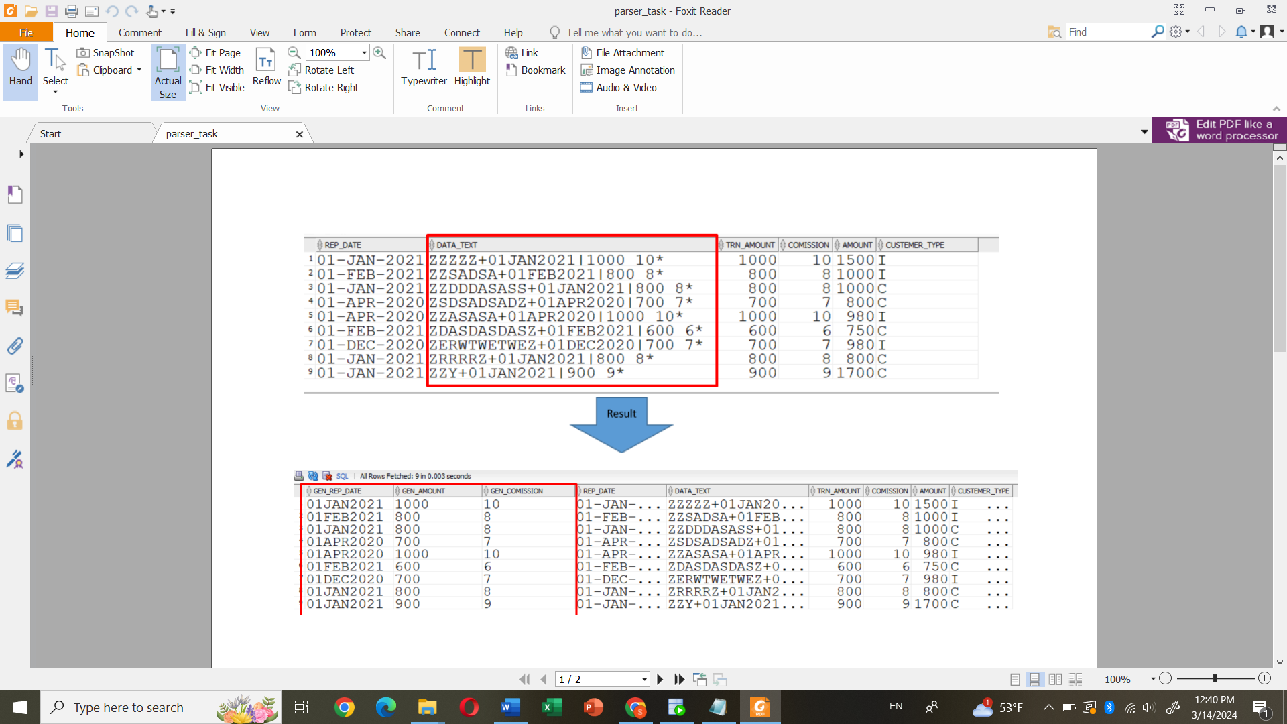

CREATE TABLE DATA_PARSE22

(

DATA_TEXT VARCHAR2(800),

AMOUNT NUMBER);

Insert into DATA_PARSE22 (DATA_TEXT,AMOUNT) values ('ZZZZZ+01JAN2021|1000 10*',1500);

Insert into DATA_PARSE22 (DATA_TEXT,AMOUNT) values ('ZZRER+01FEB2021|800 8* ',1000);

Insert into DATA_PARSE22 (DATA_TEXT,AMOUNT) values ('ZEEZ+01JAN2021|800 8* ',1000);

Insert into DATA_PARSE22 (DATA_TEXT,AMOUNT) values ('ZZZZ+01APR2020|700 7* ',800);

Insert into DATA_PARSE22 (DATA_TEXT,AMOUNT) values ('ZZZ+01APR2020|1000 10* ',1280);

Insert into DATA_PARSE22 (DATA_TEXT,AMOUNT) values ('Z+01FEB2021|600 6* ',750);

Insert into DATA_PARSE22 (DATA_TEXT,AMOUNT) values ('ZUYTTTEDZ+01DEC2020|700 7* ',980);

Insert into DATA_PARSE22 (DATA_TEXT,AMOUNT) values ('ZZ+01JAN2021|800 8* ',2790);

Insert into DATA_PARSE22 (DATA_TEXT,AMOUNT) values ('ZZZDFSFSDFSDFDSZ+01JAN2021|900 9* ',1700);

commit;

select * from DATA_PARSE22;

SELECT

SUBSTR(DATA_TEXT, INSTR(DATA_TEXT, '+', 1, 1) + 1, INSTR(DATA_TEXT, '|', 1, 1) - INSTR(DATA_TEXT, '+', 1, 1) - 1) AS GEN_REP_DATE,

SUBSTR(DATA_TEXT, INSTR(DATA_TEXT, '|') + 1, INSTR(DATA_TEXT, ' ') - INSTR(DATA_TEXT, '|')) AS GEN_AMOUNT,

SUBSTR(DATA_TEXT, INSTR(DATA_TEXT, ' '), INSTR(DATA_TEXT, '*') - INSTR(DATA_TEXT, ' ')) AS GEN_COMMISSION, AMOUNT

FROM DATA_PARSE22;